SIM B Documentation and Analysis

**TEAM WORK**

How well did you work as a team members

* We worked as efficiently as we could given our very different schedules. We met up mostly in the evenings, and worked on the project. We divided up tasks for time maximization, and communicated errors that we had in our individual tasks. We experienced issues of scheduling conflict, live share malfunctions and system errors which we worked to solved.
* We utilized pair/team programming when we met as a team. David set up the structure of our program and implemented the data structures to be used for PCBs, process tables, and processes. Samira and Jeremy helped with suggestions and bug fixing. Samira created the scheduling algorithms as David and Jeremy helped with suggestions and alternate approaches. Jeremy created the queues and helped debug the overall program flow, ensuring that processes are assigned to queues as expected and being executed as expected.

**Analysis**

* Unfortunately, we experienced issues based with getting our data into the file. Based on our code, we made certain assumptions on the expected average wait, turnaround and response based on our different scheduling methods. For the first come first serve, the processes at the top of the list will experience a shorter wait time that those at the bottom. In a system with a lot of processes being passed in, you will expect a higher wait time for the process last ready in the system. Any issue with a process above will also lead to an increased wait time. The same applies for the response time of the processes in the first come first serve depending on when the inquiry is made. For the SPT, the process that take a shorter time to complete will have a shorter response time, wait time and turn around time because the shorter process are executed first. There is a directly proportional relation between the process length and the wait, turnaround and response time. For the Round robin, because it switches between process, the general wait time for process is not as high, but it takes a longer time for the process to reach completion which means there is a higher turnaround time.

**Graphs based on Assumptions**

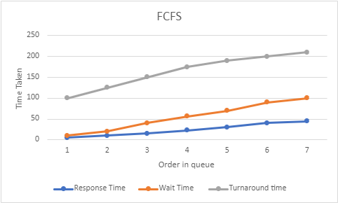

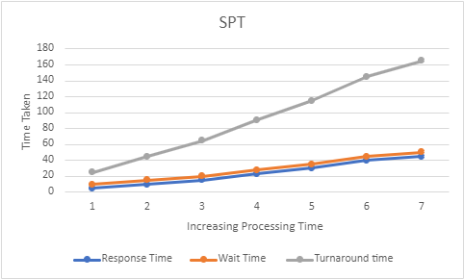

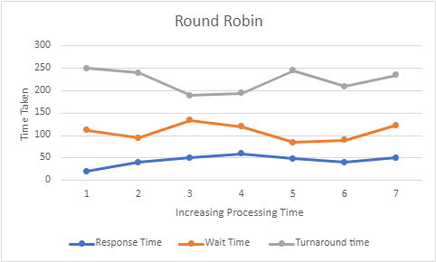

* Each processor was assigned a certain number of processes upon creation, an implementation of the Dedicated Processor Assignment approach.
* Each CPU has a fixed amount of processing time that gets used up by the amount of time every is executed.
* The program runs until the wait queue is out of processes to run. This means that there are no more processes for a specific processor to run. The program terminates when all processors’ wait queues are empty.